

Internet :

At NSAKCET seamless Internet facility is provided using optical fiber backbone, covering Class rooms, Departments, Laboratories, Exam Branch and Library throughout the campus with connectivity of 300 Mbps, 300 Mbps, 150 Mbps and 300Mbps respectively. Speed 4 Broadband lines from a highly competent Service Providers. All the computer terminal points are connected with LAN facility.

Wi-Fi facility:
Un-interrupted Wi-Fi facility is available in offices of all departments and Central facilities like
Library, Principal Office, Training and Placement Cell, Exam Branch and Computer Centre. The remaining campus including class rooms is provided with Limited access to Wi-fi. All the laboratories are under 24x7 CCTV surveillance for the physical supervision. For administrative convenience and security privilege, USB port has been disabled in all the computer terminals of all laboratories and unauthorized access of various web sites and installation of any new software is restricted using the Firewall security. The Campus also enabled with Jio Wi-Fi setup for academic blocks.
The Table below gives the details of Internet facilities provided apart from Jio Wi-Fi setup.

Internet Facilities
Name of the Internet Provider | Act Fiber Net
1). 300 Mbps ( G Block )
2). 300 Mbps ( Exam Branch )
3). 150 Mbps ( Admin Block )
4). 300 Mbps ( C Block )
Available bandwidth
Availability of Internet in an exclusive lab | Yes
Availability in most computing lab | Yes
Availability of Wi-Fi | Yes
Availability in Departments, labs, classrooms , library,  Offices and other units. | Yes
Availability in Faculty rooms | Yes
Security/privacy of e-mail/internet users | Yes

NSAKCET@Wi-Fi Campus
Jio 4G Enabled Wifi Campus

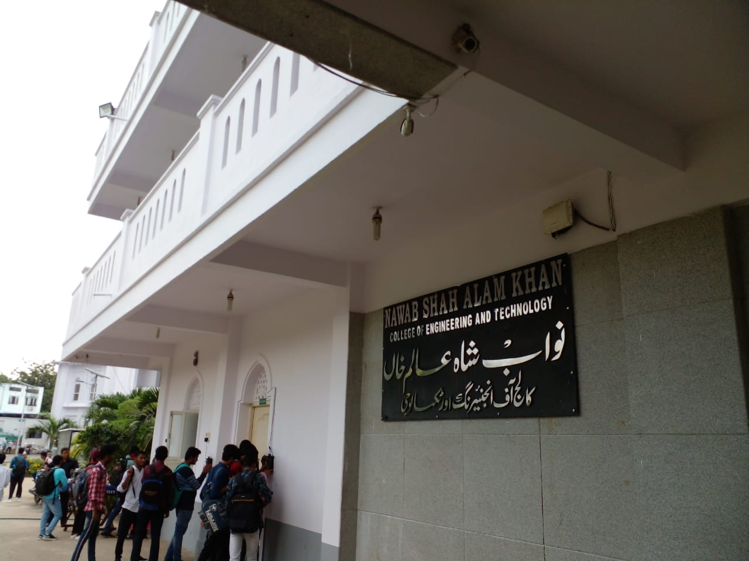
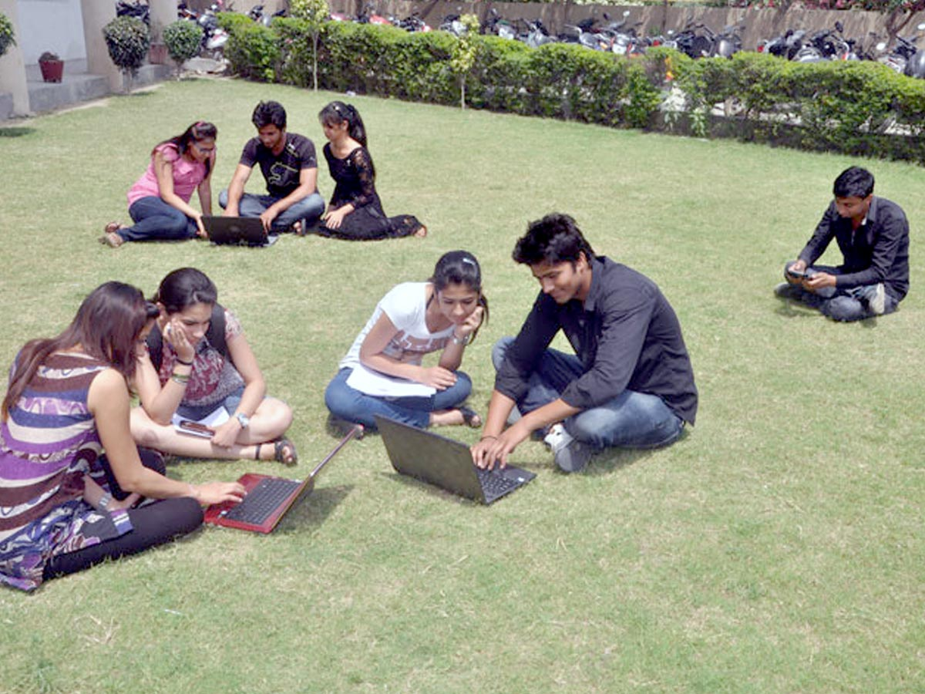

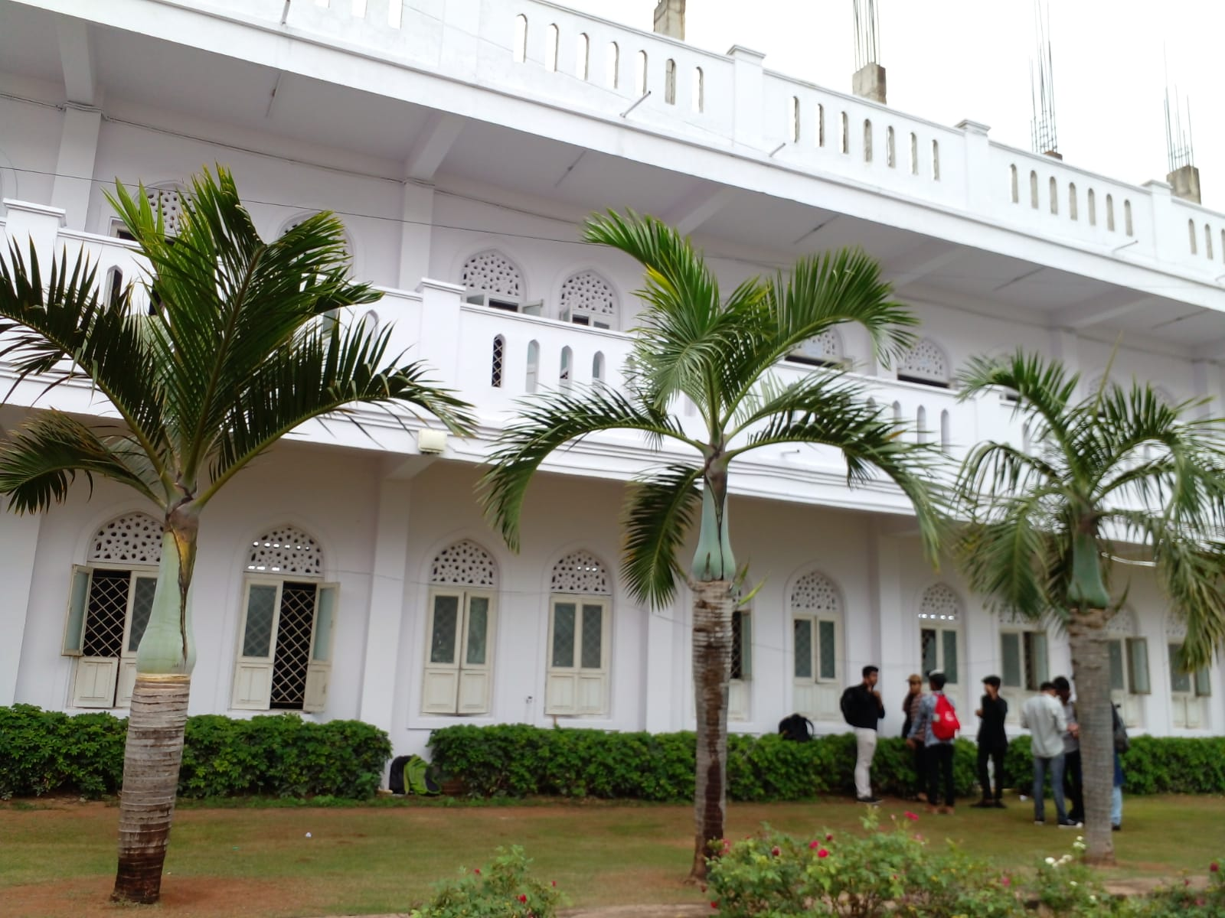
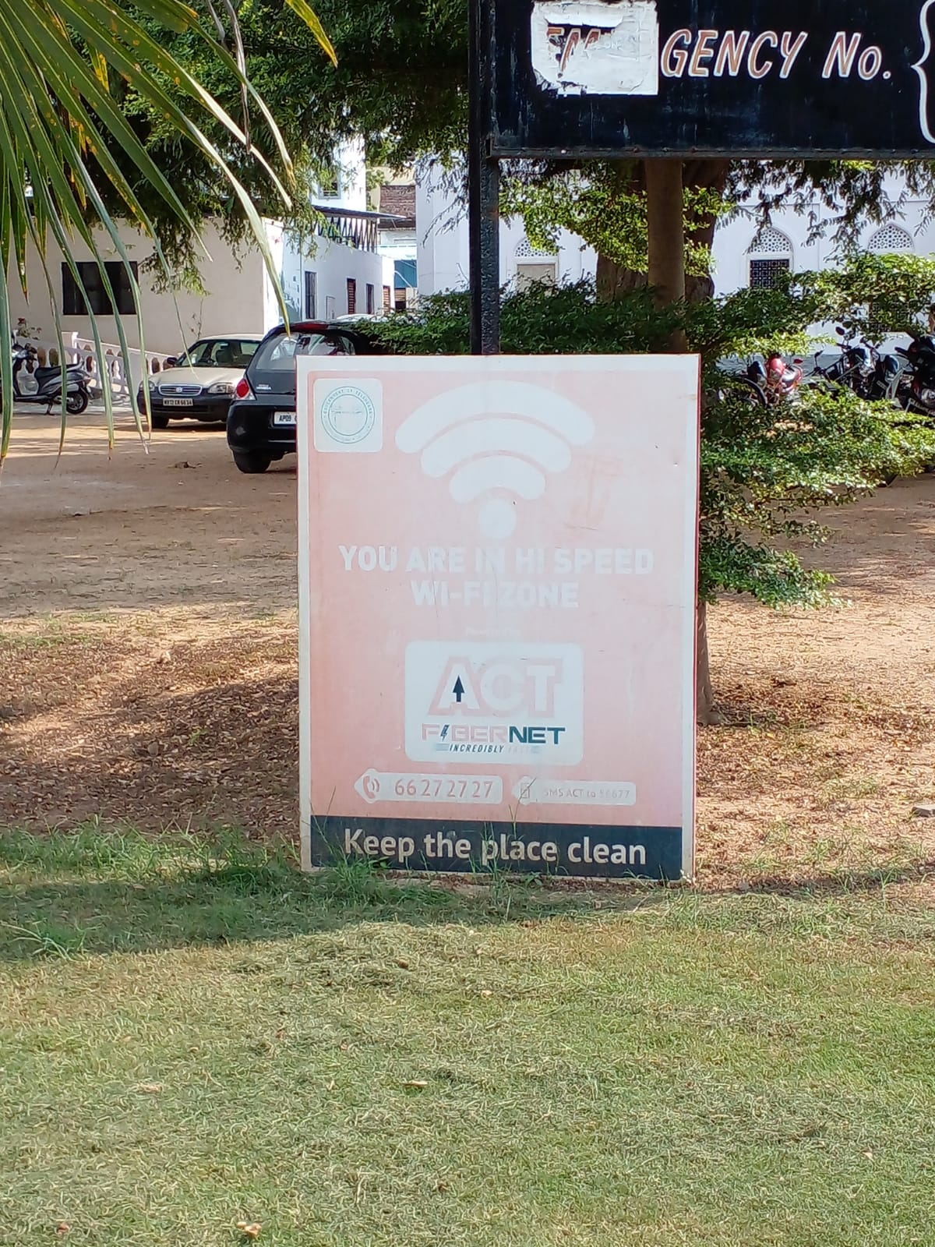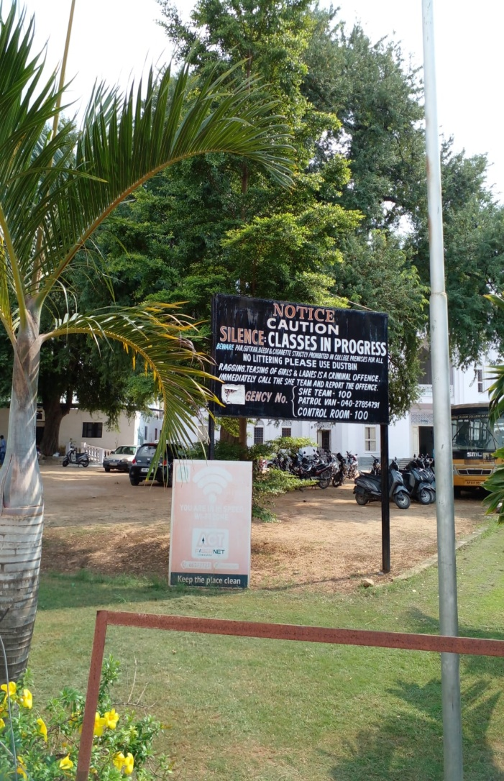

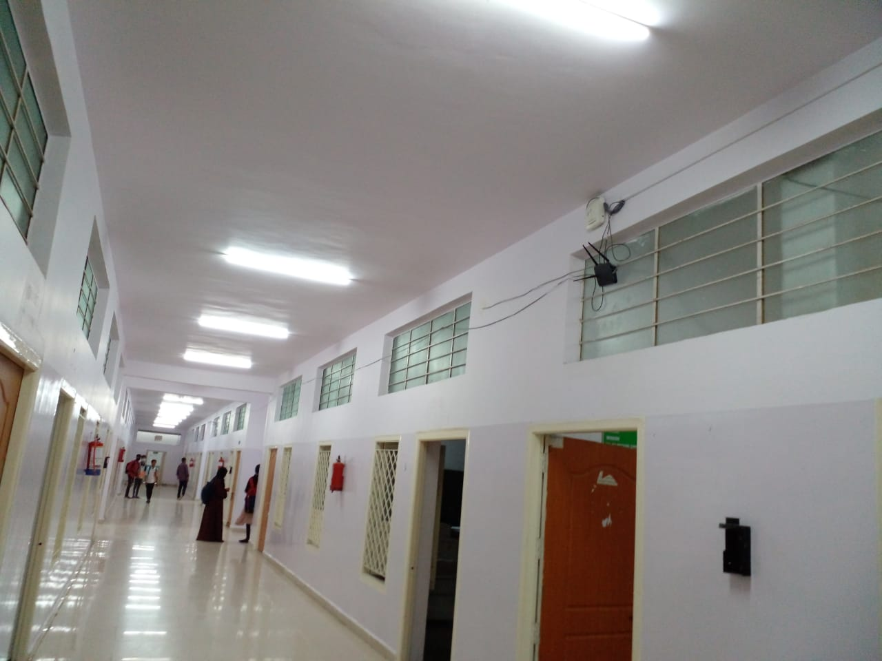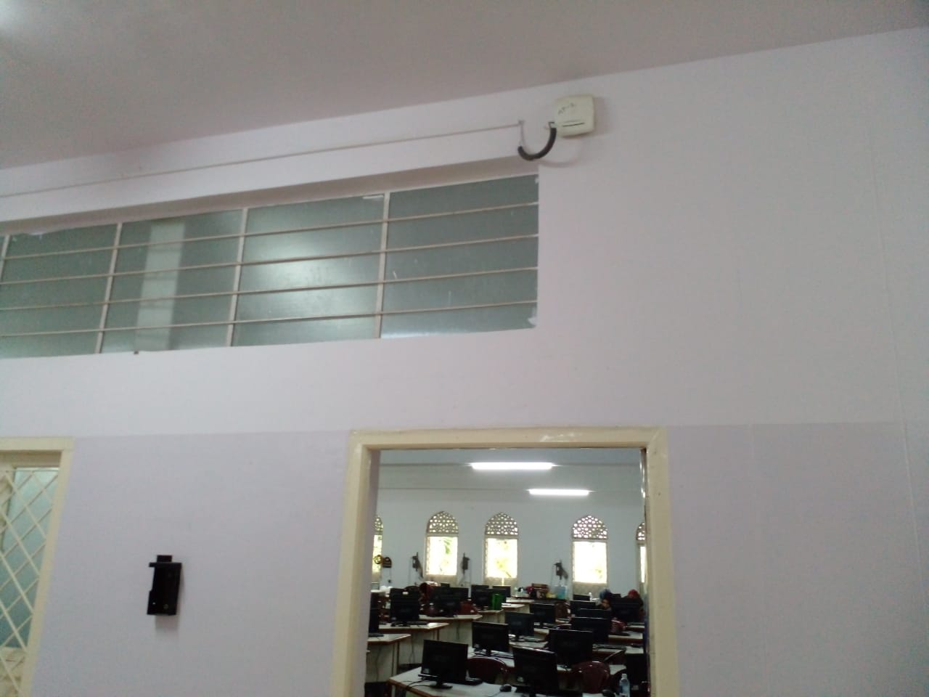
NSAKCET@Wi-Fi Campus
The entire campus is Wi-Fi enabled with a high speed internet connection to allow the students to access the internet no-matter wherever they are. The coverage of Wi-Fi is not only restricted to class rooms but also extends to all the areas including , Departments, Laboratories, Exam Branch and Computer Centre and throughout the campus. All the websites browsed by him/her are regularly monitored.

Details
- Use Laptop and Andriod
- Registration Required
- Jio 4G Wi-fi

